Supplementary Materials
A.1 Tables of Reviewed Literature

Title | Authors | Citations | Journal | Publication Year | Study Year | Study Region | Data Granularity | Temperature Effects  on Gender
Is the association between temperature and mortality modified by age, gender and socio-economic status? | Yu et al. | 202 | Science of The Total Environment | 2010 | 1996 - 2004 | Brisbane, Australia | Daily data | A total of 53,316 (27,244 females and 26,072 males) non-external deaths were included during the study period. The effect among women (11.21% (95% CI: 5.00%, 17.41%)) was more than 20 times that among men (0.56% (95% CI: −9.20%, 10.31%)). Percent increases of total deaths in females were significantly greater than in males in the eldest age group (over 85) when we cross-classified data by age and gender.
The Impact of Heat Waves on Mortality in Seven Major Cities in Korea | Son et al. | 262 | Environmental Health Perspectives | 2012 | 2000 - 2007 | Seven Major Cities in South Korea | Daily data | Sample size of mortality data and summary statistics for gender data are not provided. The total daily average mortality count is 215.3 for the seven cities. Estimated heat wave effects were not significantly different by sex, age, education level, or place of death in Seoul but were higher for females (15.9%; 95% CI: 2.9%, 30.5%) than males (2.5%; 95% CI: –7.6%, 13.8%)
Heat- and cold-stress effects on cardiovascular mortality and morbidity among urban and rural populations in the Czech Republic | Urban et al. | 113 | International Journal of Biometeorology | 2013 | 1994 - 2009 | Czech Republic | Daily data | The sample consists of 1174618 morbidity counts and 211546 mortality counts. Gender summary statistics are not provided. In both regions and for all groups of diagnoses as well as for individual CVDs except for atherosclerosis, excess mortality was greater in females than males. In females, excess mortality was, in both regions, significant for all groups of diagnoses other than MI.
Susceptibility to mortality related to temperature and heat and cold wave duration in the population of Stockholm County, Sweden | Rocklov et al. | 152 | Global Health Action | 2014 | 1990 - 2002 | Stockholm County, Sweden | Daily data | Mortality data for summer months consists of 44738 deaths, where 20973 cases are males (46.88%) and 23765 cases are females (53.12%).The mortality data for winter months include 51438 deaths, where 23710 are male (46.1%) and 27728 are female (53.91%). The study found strong increases in mortality associated with heat wave duration among the populations less than age 65, with the largest risk increases in women and less wealthy municipalities.
The impact of heatwaves on mortality in Australia: a multicity study | Tong et al. | 121 | BMJ Open | 2014 | 1988 - 2009 | Three Major Cities in Australia | Daily data | Summary statistics of the mortality data are not provided. The 1988-2009 averaged summer months' mortality counts of the three cities are 71 for males and 68 for females. Heatwaves also appeared to have a greater impact on females and total mortality. For example, the relative risk (RR) for total mortality in Brisbane, Melbourne and Sydney was 1.13 (95% CI 1.08 to 1.19), 1.10 (95% CI 1.06 to 1.14) and 1.06 (95% CI 1.01 to 1.10), respectively, at lag 1.

Table S.1 Selected studies of temperature-related mortality from Global North. Studies with gender-stratified models that were conducted after 2010 with more than 100 citations are selected from the review paper Benmarhnia et al. (2015)¹, yielding five studies. Four of the five studies (colored in pink) concluded women are at higher risk of mortality in extreme temperatures. One of the five studies reported no gender differences (shaded in gray).

Title | Authors | Citations | Journal | Publication Year | Study Year | Study Region | Data Granularity | Temperature Effects  on Gender
Vulnerability to heat-related mortality in Latin America: a case-crossover study in São Paulo, Brazil, Santiago, Chile and Mexico City, Mexico | Bell et al. | 345 | International journal of epidemiology | 2008 | 1998 - 2002 | São Paulo, Brazil, Santiago, Chile, and Mexico City, Mexico | Daily data | A total of 754291 deaths were included. There are 51.1% male data in Santiago, 53.1% male data in São Paulo, and 50.1% male data in Mexico City. Percentage increase in heat mortality risk at the 95th percentile of mean apparent temperature compared with the 75th percentile (95% CI) by sex: Male in Santiago 1.98 (−3.42 to 7.68), in São Paulo 4.59 (1.76 to 7.50), in Mexico City 0.78 (−1.54 to 3.15); Female in Santiago 1.65 (−3.90 to 7.50), in São Paulo 4.25 (1.25 to 7.34), in Mexico City 1.75 (−0.57 to 4.13)
The impact of the 2003 heat wave on mortality in Shanghai, China | Huang et al. | 234 | Science of The Total Environment | 2010 | 2003 | Shanghai, China | Daily data | The mortality data for the reference period consists of 2025 deaths, where 1053 cases are males (52%) and 972 cases are females (48%). The mortality data of the heatwave periods include 2283 deaths, where 1217 are male (53.31%) and 1066 are female (46.69%). The effect of heat waves on total mortality in males was slightly higher than in females, but the difference was not statistically significant. This finding is consistent with a previous study showing no differences of temperature health effects across genders (O'Neill et al., 2003).
The association of weather and mortality in Bangladesh from 1983–2009 | Alam et al. | 32 | Global Health Action | 2012 | 1983 - 2009 | Bangladesh | Weekly data | The mortality data consists of 4850 deaths, summary statistics of gender is not provided. Low temperature (below 75th percentile) was associated with increased mortality risk of females, but not males. Temperature above the 75th percentile was not associated with mortality risk of any sex and age group.
A study of intracity variation of temperature-related mortality and socioeconomic status among the Chinese population in Hong Kong | Chan et al. | 235 | Journal of Epidemiology and Community Health | 2012 | 1998 - 2006 | Hong Kong, China | Daily data | The mortality data consists of 129,688 non-accidental deaths, where 72,148 cases are males (55.63%) and 57,538 cases are females (44.37%). Deaths among women (RR 1.068, 95% CI 1.017 to 1.121, p = 0.008) were more sensitive to higher temperatures than among men (RR 1.045, 95% CI 1.001 to 1.092, p = 0.046).
Time-series analysis of weather and mortality patterns in Nairobi's informal settlements | Egondi et al. | 121 | Global Health Action | 2012 | 2003 - 2008 | Nairobi, Kenya | Daily data | The mortality data consists of 2512 deaths, 1332 deaths were male (53%) and 1180 deaths were female (47%). The results show no significant relationship for high temperature on all mortality. Deaths among males and people  aged 50 were associated with low temperatures though these relationships were not statistically significant.
The short-term association of temperature and rainfall with mortality in Vadu Health and Demographic Surveillance System: a population level time series analysis | Ingole et al. | 31 | Global Health Action | 2012 | 2003 - 2010 | Pune, India | Daily data | The mortality data consists of 1662 deaths, 954 deaths were male (57.4%) and 708 were female (42.6%). Strong associations with temperature and rainfall exist for all-cause mortality over all age groups. The effects could be seen for both high and low temperatures, and up to 2 weeks following rainfall. In particular, the associations were strongest among children, women, and the elderly.
The association of meteorological factors and mortality in rural Bangladesh, 1983–2009 | Lindeboom et al. | 39 | Global Health Action | 2012 | 1983 - 2009 | Bangladesh | Monthly and bimonthly data | 48,238 deaths were registered, summary statistics of gender is not provided. Association of heat mortality with combined lags mean temperature after adjusting for trend and seasonality: -3.2 (−5.1, −1.3) for male under 25th percentile, -2.9 (−4.6, −1.2) for male in 25-75th percentile, 0.2 (0.0, 0.4) for male over 75th percentile; -2.2 (−4.3, −0.2) for female under 25th percentile, -2.3 (−4.1, −0.5) for female in 25-75th percentile, 0.2 (−0.1, 0.4) for female over 75th percentile
Daily temperature and mortality: a study of distributed lag non-linear effect and effect modification in Guangzhou | Yang et al. | 245 | Environmental Health | 2012 | 2003 - 2007 | Guangzhou, China | Daily data | The mortality data includes 112280 cases of deaths. Summary statistics for gender are not provided. Hot effects were significantly larger for females than males. On the contrary, males were at higher risk of cold effects compared to females but the difference was non-significant.
Heat-Related Mortality in India: Excess All-Cause Mortality Associated with the 2010 Ahmedabad Heat Wave | Azhar et al. | 294 | PLOS ONE | 2014 | 2009 - 2011 | Ahmedabad, India | Daily data | 115998 cases of deaths are considered in the study, 68977 are men (59.46%) and 47021 are women (40.54%). The gender distribution highlights significantly more female deaths in the summer months and the heat wave period.
Temperature and mortality on the roof of the world: A time-series analysis in three Tibetan counties, China | Bai et al. | 67 | Science of The Total Environment | 2014 | 2008 - 2012 | Tibet, China | Daily data | 5610 cases of non-accidental deaths are considered in the study. There are 60.3% male data in Chengguan, 57.1% male data in Naidong, and 50.9% male data in Jiangzi. Males, elders (≥ 65 years), illiterate persons and those with cardiovascular illness tend to be at higher risks of dying from extreme temperatures.
An analysis of heat effects in different subpopulations of Bangladesh | Burkart et al. | 65 | International Journal of Biometeorology | 2014 | Not Specified | Bangladesh | Daily data | In total, 22,840 deaths were analyzed. 13091 deaths were male (57.34%) and 9743 deaths were female (42.66%). For the elderly (above 65 years), men face higher heat-related mortality. An increase in all-cause mortality was observed for men, which was estimated as 45.9 % (95%CI: 39.7–59.0). Heat effects for women were smaller, with an increase of 24.3 % (95%CI: 16.9–38.8 %) above the threshold temperature.
Impact of Heat and Cold on Total and Cause-Specific Mortality in Vadu HDSS—A Rural Setting in Western India | Ingole et al. | 31 | International Journal of Environmental Research and Public Health | 2015 | 2003 - 2012 | Pune, India | Daily data | 2302 deaths were analyzed, summary statistics for gender is not provided. There was less evidence for an effect of heat days on total mortality among women and elderly in this population. Relative risks among men and age group 12–59 years were higher than in women and elderly, and statistically significant. We did not find any association of cold days and mortality by cause of death, sex and age group.
Characterizing the Impact of Extreme Heat on Mortality, Karachi, Pakistan, June 2015 | Ghumman and Horney | 46 | Prehospital and Disaster Medicine | 2016 | 2015 | Karachi, Pakistan | Daily data | Mortality data for the reference period have 69 deaths, 48 males (69.57%) and 21 females (39.43%). The mortality data of the heatwave periods include 1220 deaths, where 838 are male (68.69%) and 382 are female (31.31%). Gender is not a significant risk factor for heat-related mortality in the study period compared to the reference period.
Socioenvironmental factors associated with heat and cold-related mortality in Vadu HDSS, western India: a population-based case-crossover study | Ingole et al. | 43 | International Journal of Biometeorology | 2017 | 2004 - 2013 | Pune, India | Surveillance rounds data | The mortality data consists of 3079 deaths, 1861 deaths were male (60.44%) and 1218 deaths were female (39.56%). Women had a higher risk of heat-related mortality than men (OR 1.91, CI = 1.07–3.47). No differences in heat and cold risks across subgroups were statistically significant.
Temperature extremes and infant mortality in Bangladesh: Hotter months, lower mortality | Bababola et al. | 22 | PLOS ONE | 2018 | 1982 - 2008 | Bangladesh | Monthly data | There were 49,426 under-five child deaths considered in the study, summary statistics of gender are not provided. Although the coefficient of temperature-induced mortality was larger in boys relative to girls, some of our estimates lacked precision so we cannot assert with confidence that there is a statistically significant difference between boys and girls.
Attributing mortality from temperature extremes: A time series analysis in Varanasi, India | Singh et al. | 56 | Science of The Total Environment | 2019 | 2009-2016 | Varanasi, India | Daily data | 64712 deaths are considered in the study, 38640 are male (59.71%) and 26072 are female (40.29%). For cold spells, there was no significant difference in the RR between genders. However, for heat waves, the RR for males (RR 1.09, 95% CI: 0.99–1.20) was much smaller than for females (RR 1.22, 95% CI: 1.09–1.37).

Table S.2 Selected studies of temperature-related mortality focused on the Global South. Studies with gender-stratified models are selected from Benmarhnia et al. (2015)¹ and Dimitrova et al. (2021)², resulting in 16 studies. Seven of the 16 studies concluded women are at higher risk in extreme temperatures (shaded in pink). Six of the 16 studies reported men being more vulnerable to extreme temperatures (shaded in blue). Three of the 16 studies reported no gender differences (shaded in gray).
A.2 Trend of Summer and Winter Monthly Temperatures from 1990 to 2019

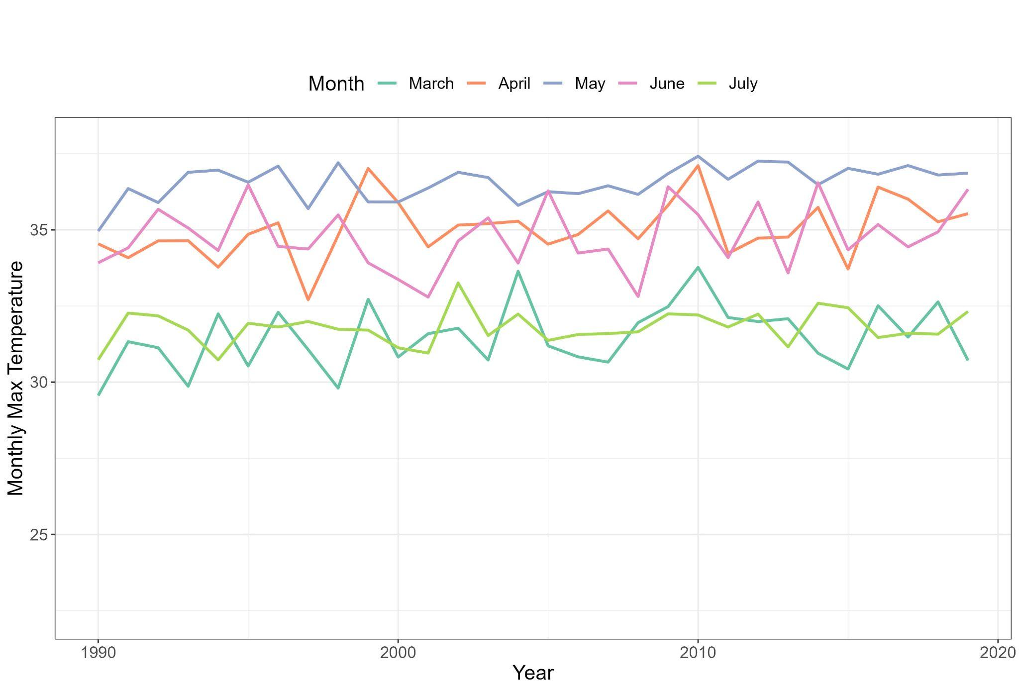
- Monthly-averaged daily max temperatures of March, April, May, June, and July

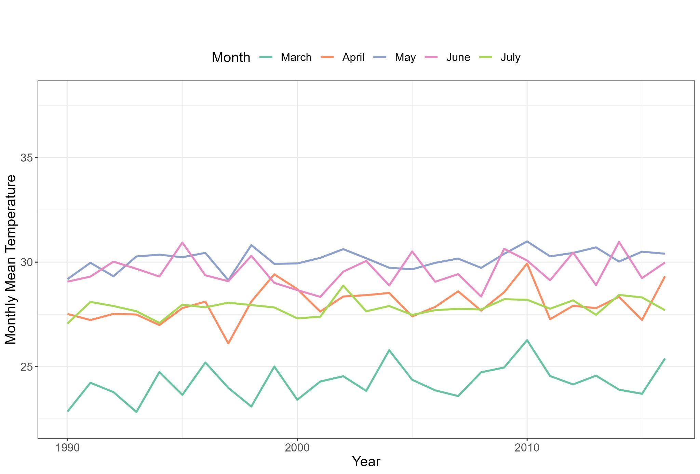
- Monthly-averaged daily mean temperatures of March, April, May, June, and July

Figure S.1 Time series plot of the monthly-averaged daily max and mean temperature of March, April, May, June, and July from 1990 to 2019. The range of summer months was determined with similar monthly averaged max temperatures. Panel (a) shows the monthly-averaged daily max temperatures; Panel (b) shows the monthly-averaged daily mean temperatures. Temperature units are in Celsius degrees. Data are obtained from IMD via Python package “IMDLIB”.

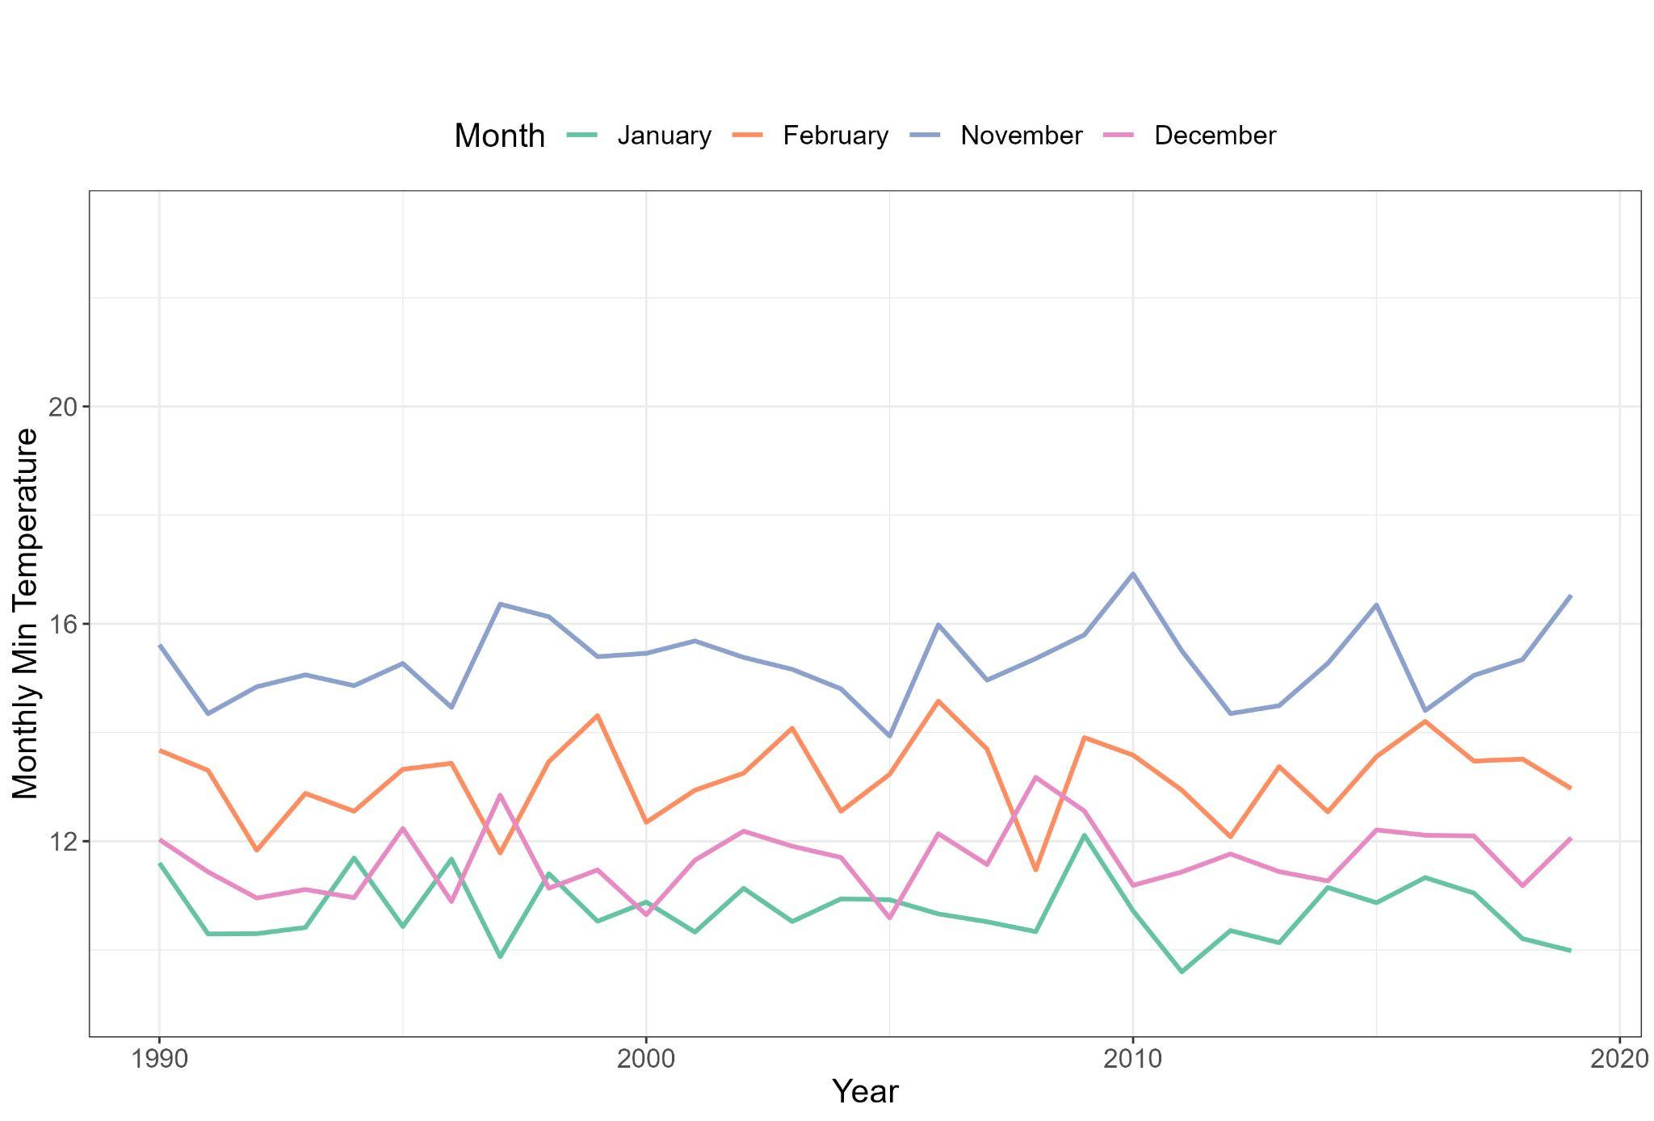
- Monthly-averaged daily min temperatures of November, December, January, and February

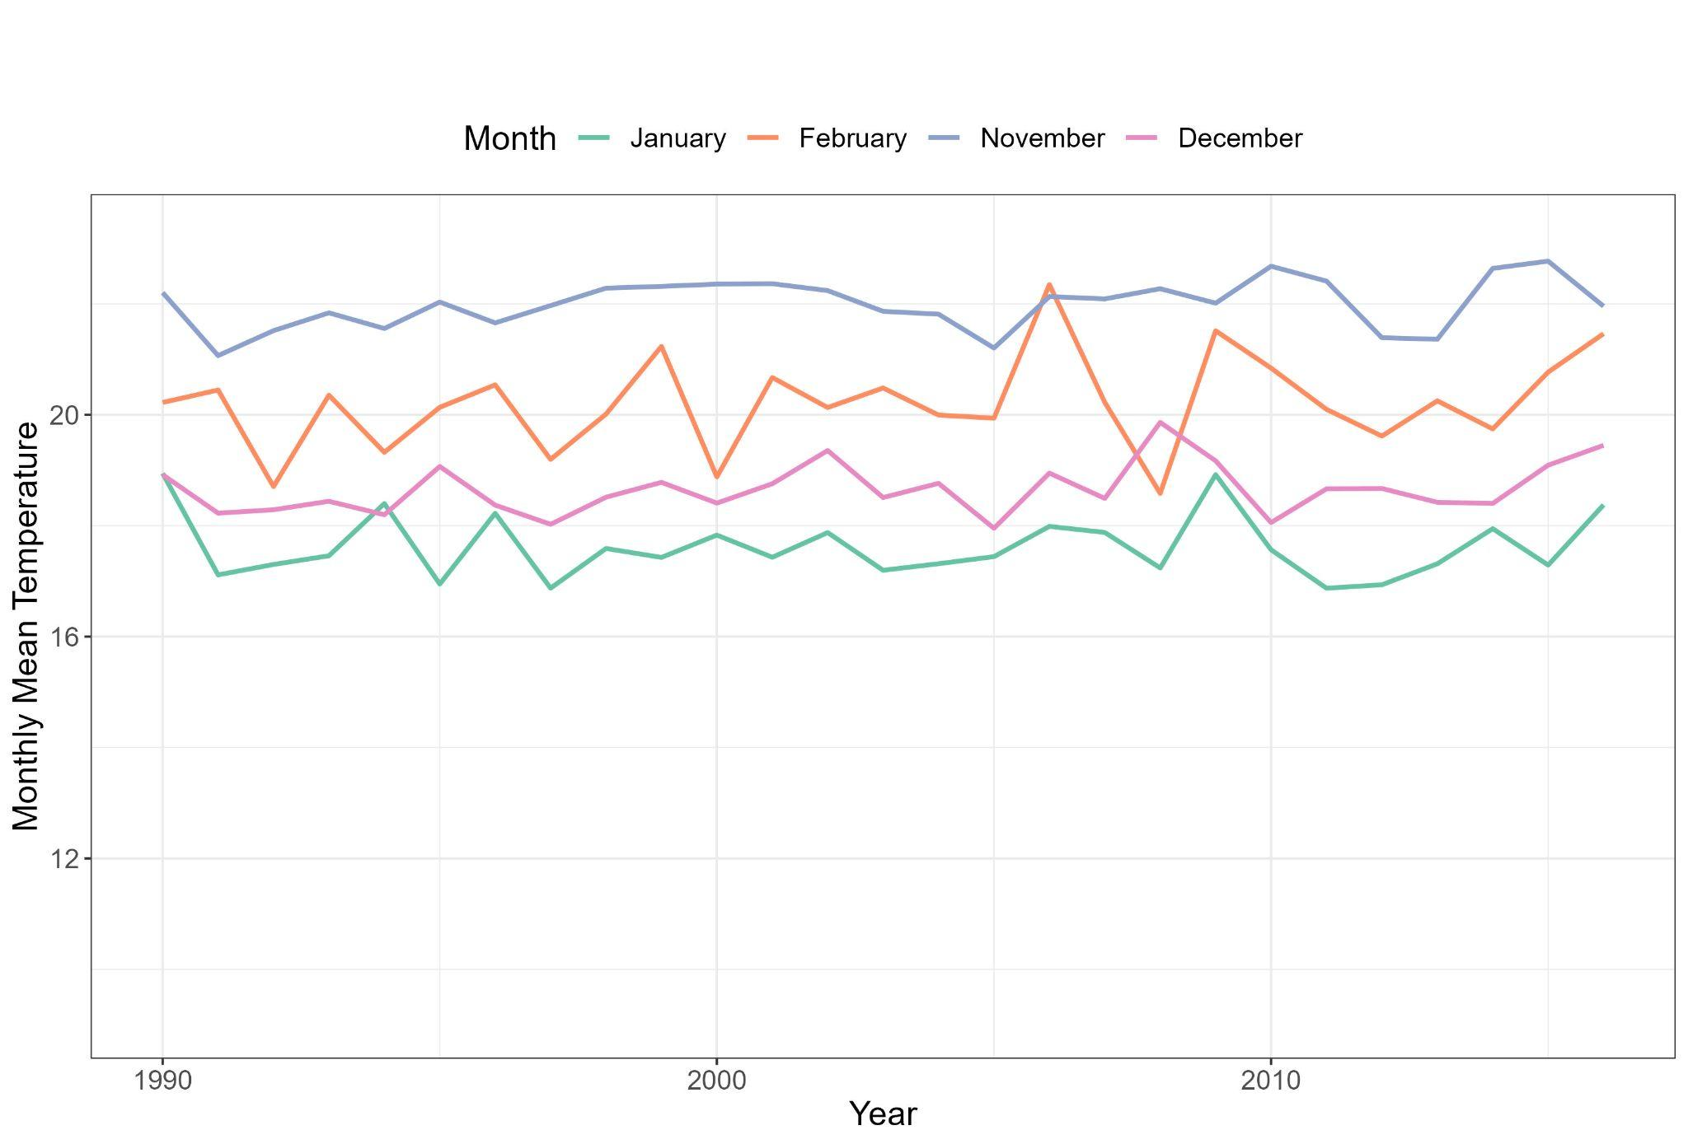
- Monthly-averaged daily mean temperatures of November, December, January, and February

Figure S.2 Time series plot of the monthly-averaged daily mean temperature of November, December, January, and February from 1990 to 2019. The range of winter months was determined with similar monthly averaged minimum temperatures. Panel (a) shows the monthly average daily minimum temperatures; Panel (b) shows the monthly average daily mean temperatures. Temperature units are in Celsius degrees. Data are obtained from IMD via Python package “IMDLIB”.

A.3 Autocorrelation Plots of Current Mortality and Temperature Data

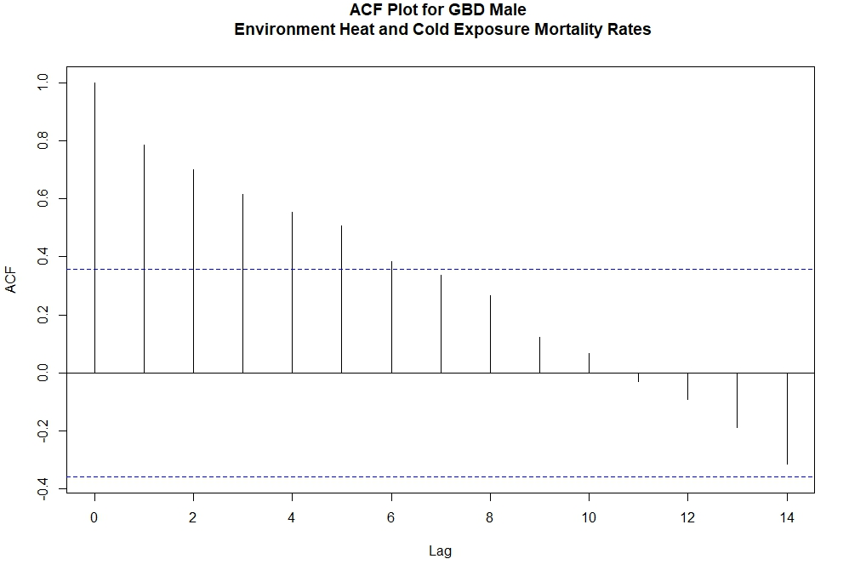
- Indian male environmental heat and cold exposure mortality rates

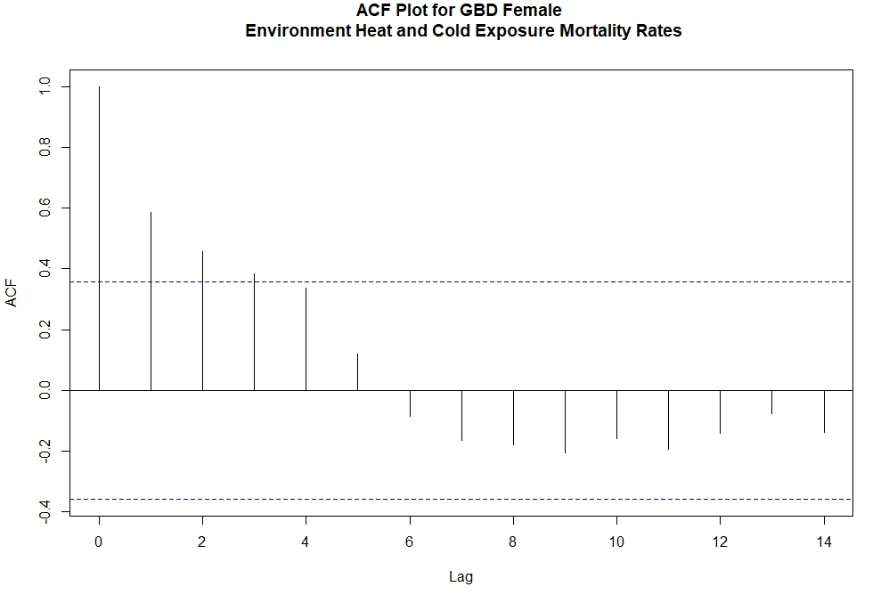
- Indian female environmental heat and cold exposure mortality rates

Figure S.3 Autocorrelation plot of the Indian gender-specific environmental heat and cold exposure mortality rates from 1990 to 2019. Panel (a) shows the mortality rates of Indian males; Panel (b) shows the mortality rates of Indian females. Mortality data and population data are obtained from the Global Burden of Disease Database.
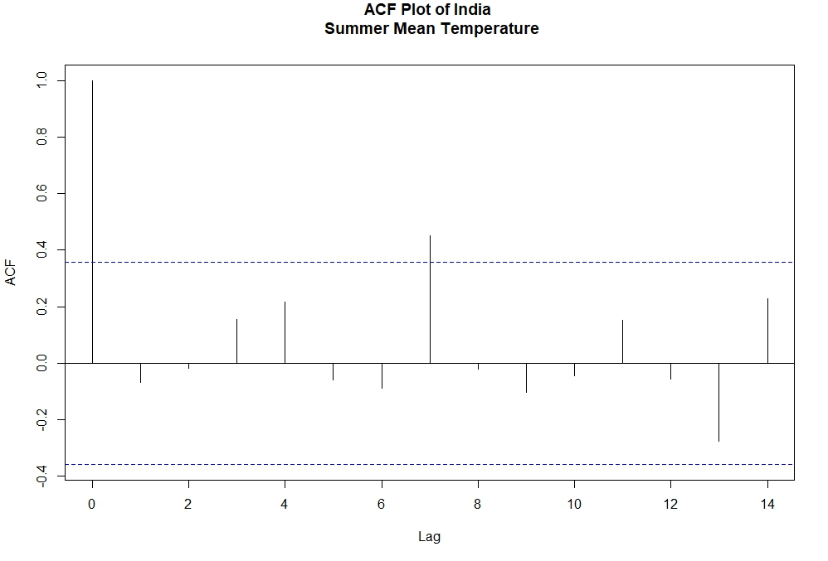
- Summer months averaged daily mean temperature

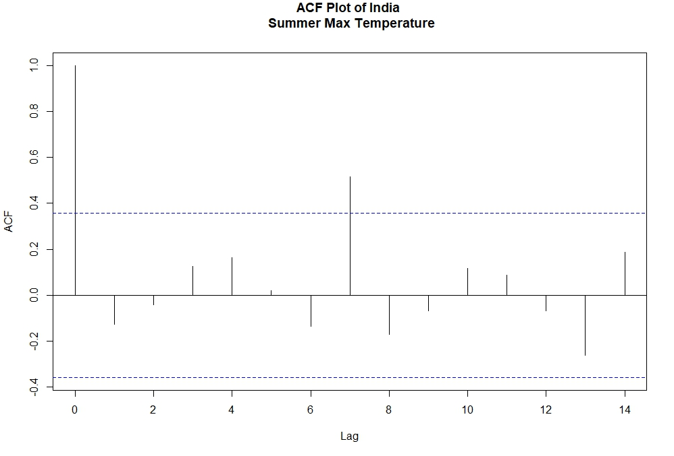
- Summer months averaged daily max temperature

Figure S.4 Autocorrelation plot of the summer months (April, May, June, and July) averaged daily mean and max temperature from 1990 to 2019. Panel (a) shows the summer months average daily mean temperature; Panel (b) shows the summer months average daily max temperature. Temperature data are obtained from IMD via Python package “IMDLIB”.

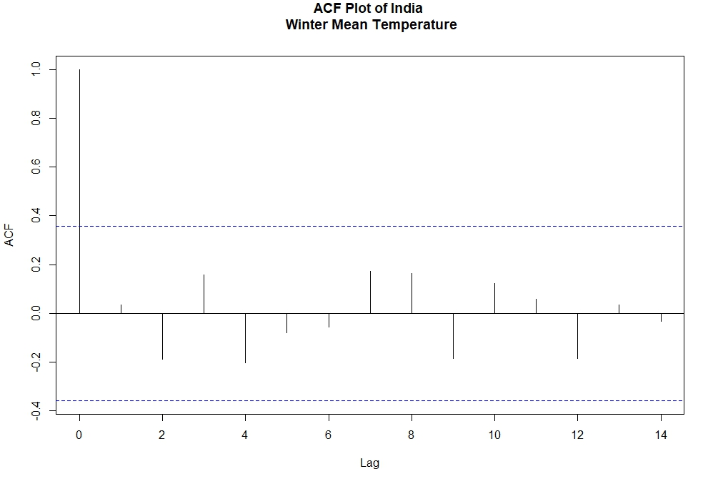
- Winter months averaged daily mean temperature

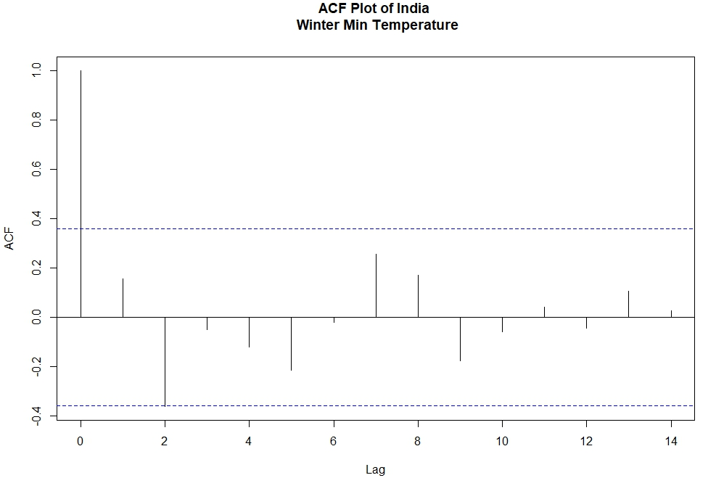
- Winter months averaged daily minimum temperature

Figure S.5 Autocorrelation plot of the winter months (December, January, and February) averaged daily mean and minimum temperature from 1990 to 2019. Panel (a) shows the winter months' average daily mean temperature; Panel (b) shows the winter months' average daily minimum temperature. Temperature data are obtained from IMD via Python package “IMDLIB”.

A.4 Autocorrelation Plots of Monthly Averaged Temperatures

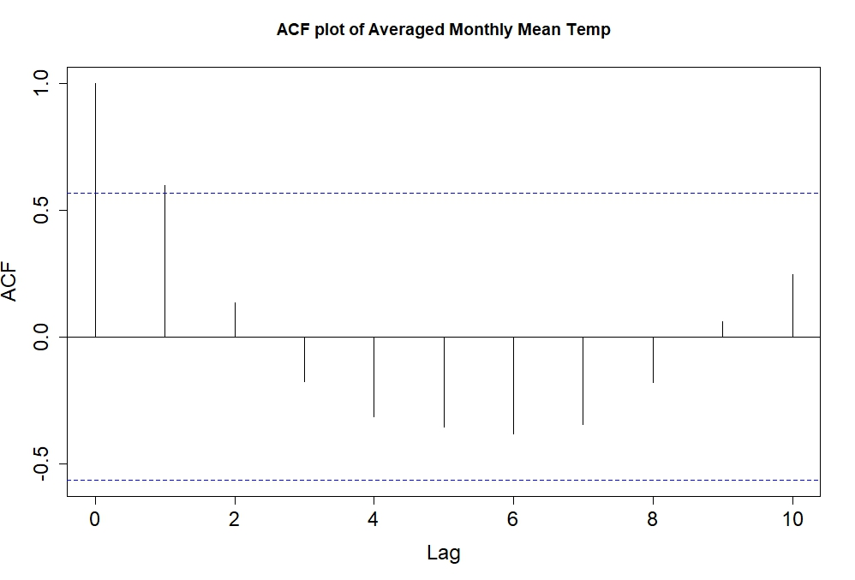
- ACF plot of averaged monthly max temperature from 1990 to 2019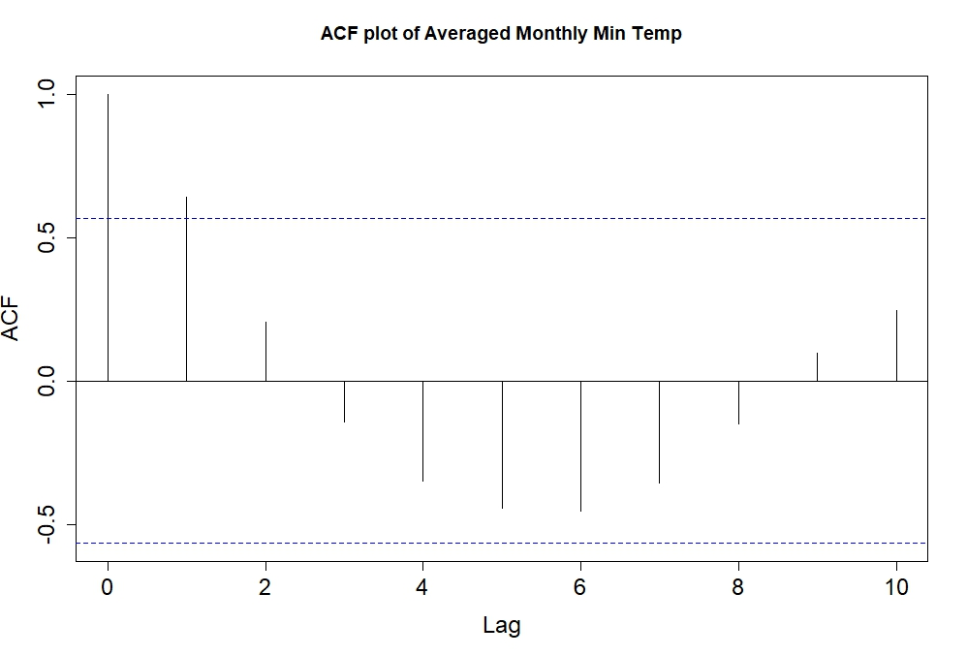
(b) ACF plot of averaged monthly mean temperature from 1990 to 2019

- ACF plot of averaged monthly minimum temperature from 1990 to 2019

Figure S.6 Autocorrelation plot of the yearly average monthly maximum, mean, and minimum temperature from 1990 to 2019. Panel (a) is the autocorrelation plot of the monthly maximum temperature; Panel (b) is the autocorrelation plot of the monthly mean temperature; Panel (c) is the autocorrelation plot of the monthly minimum temperature. Temperature data are obtained from IMD via Python package “IMDLIB”.

A.5 Monthly Moving Average Maps of Spatial Distribution of Temperature

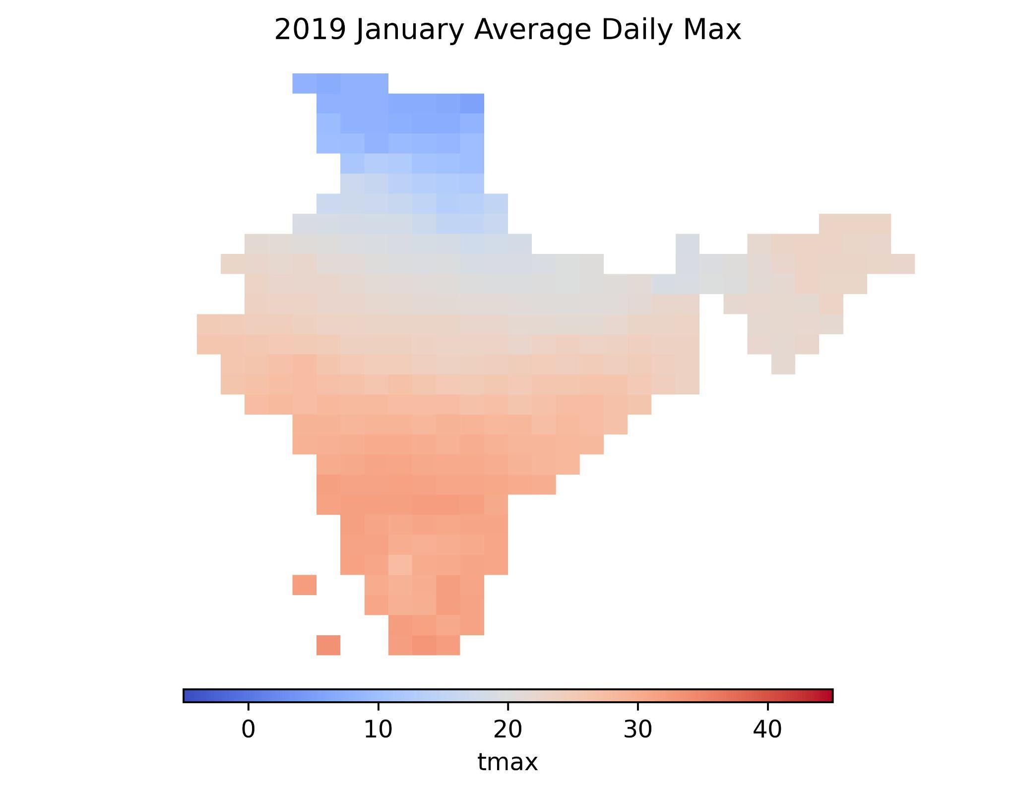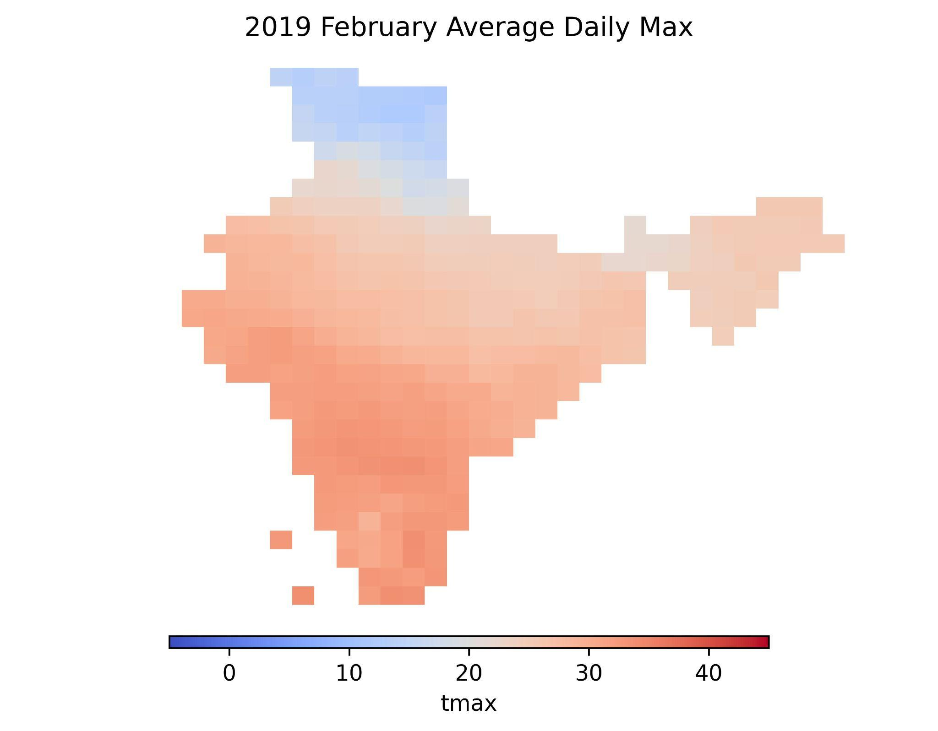
- 2019 January (b) 2019 February

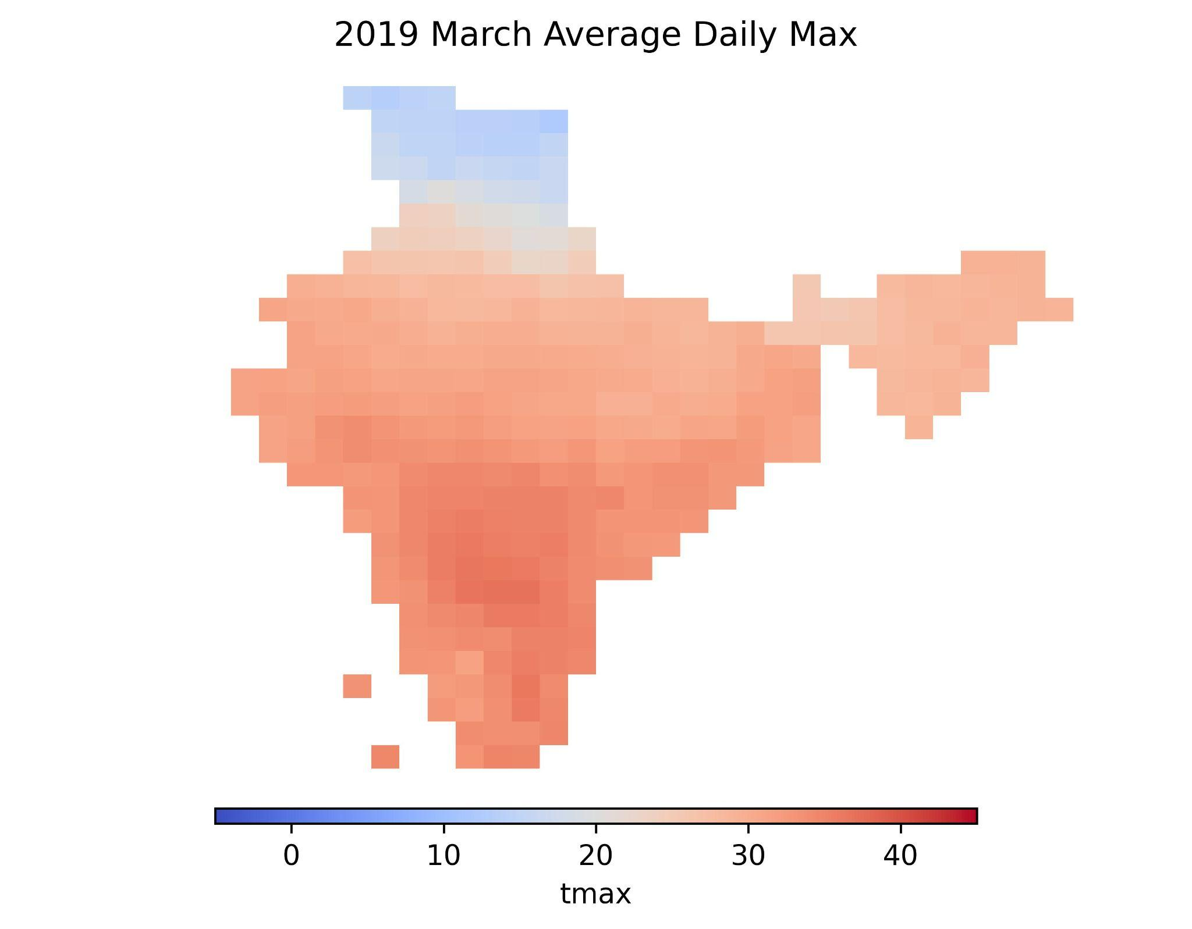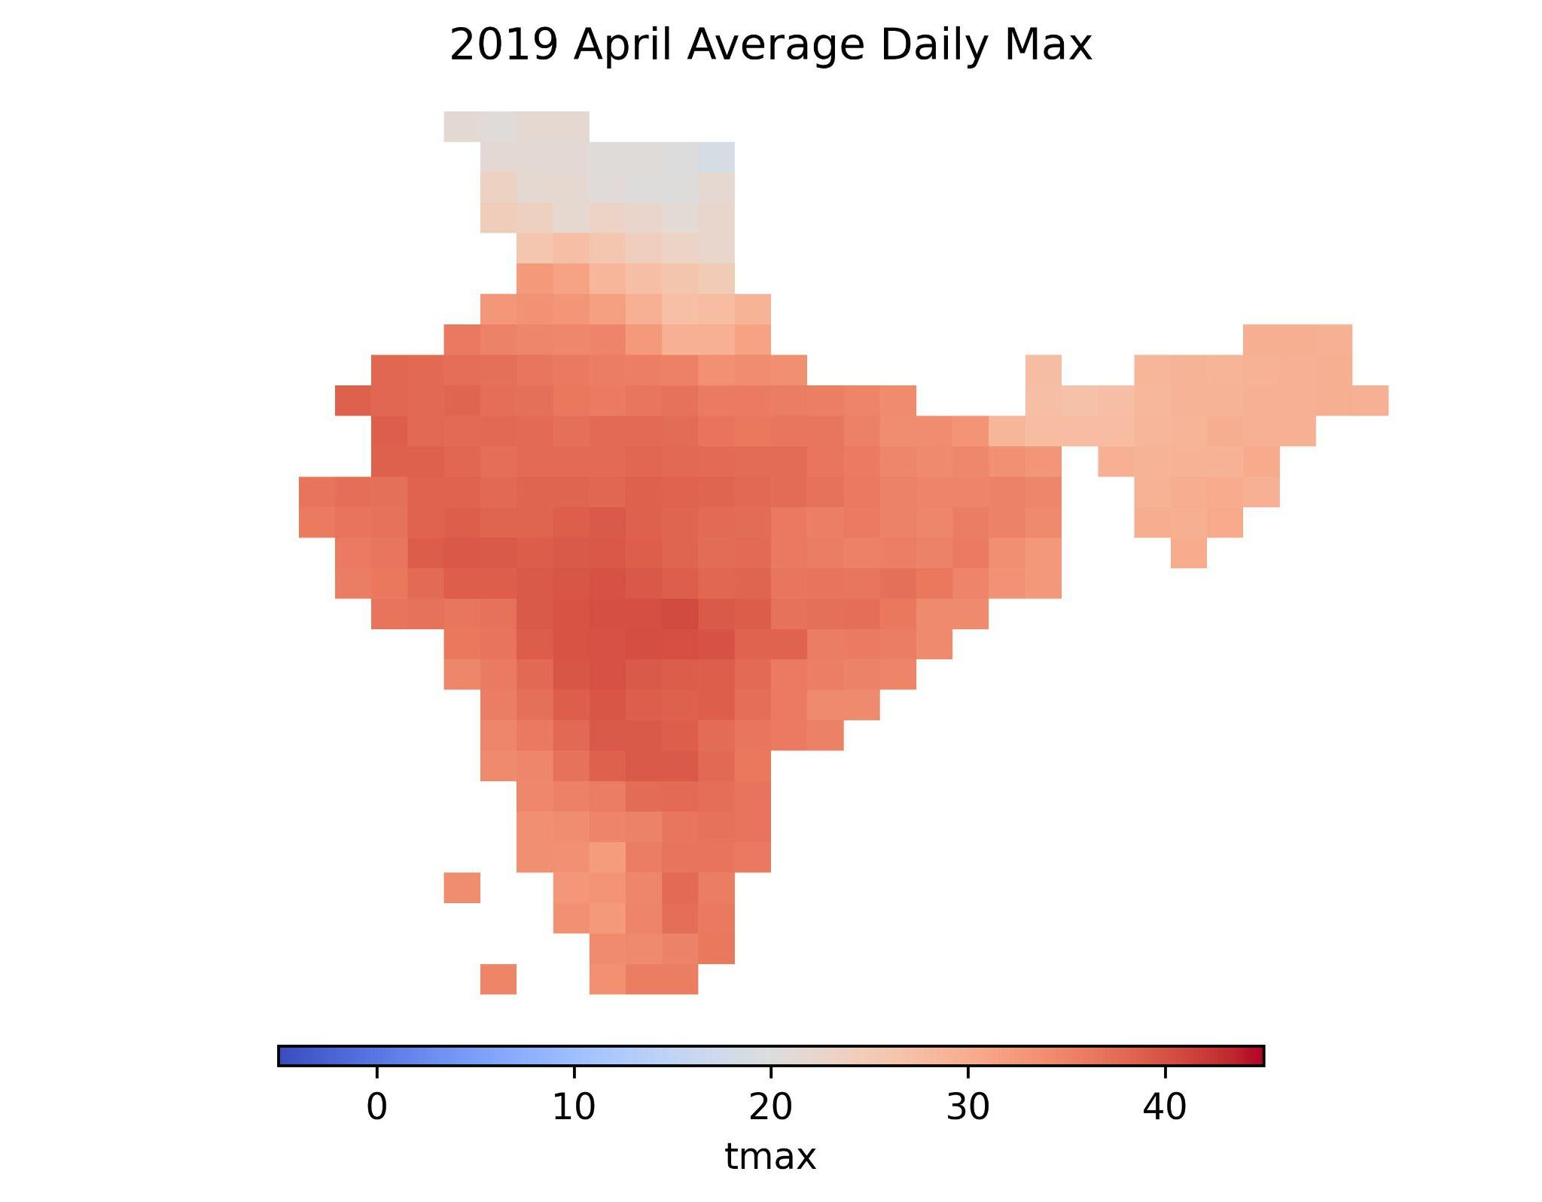
- 2019 March (d) 2019 April

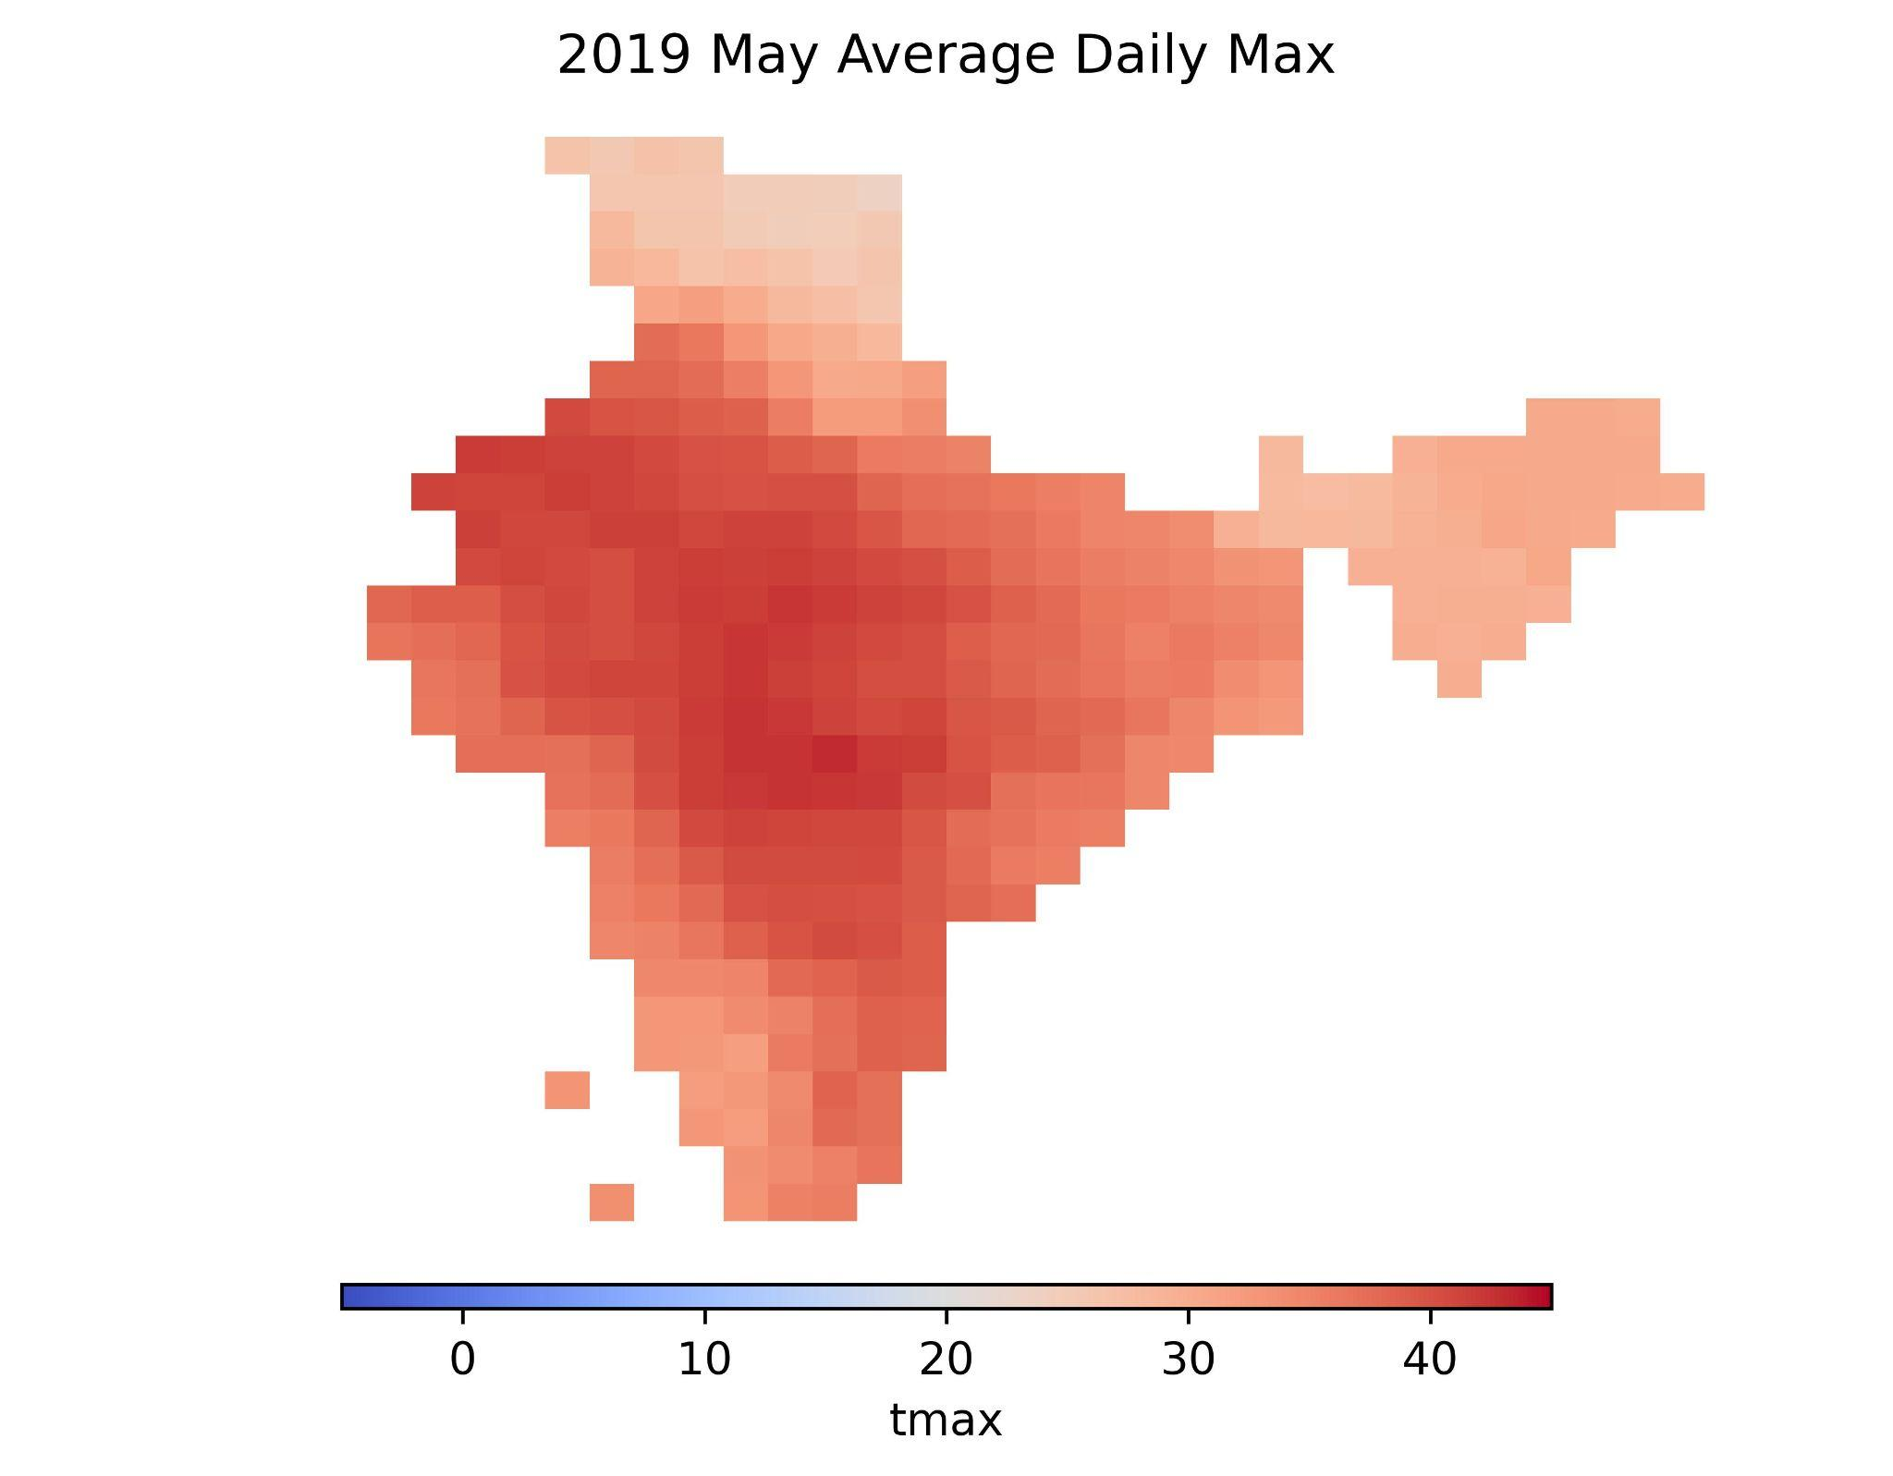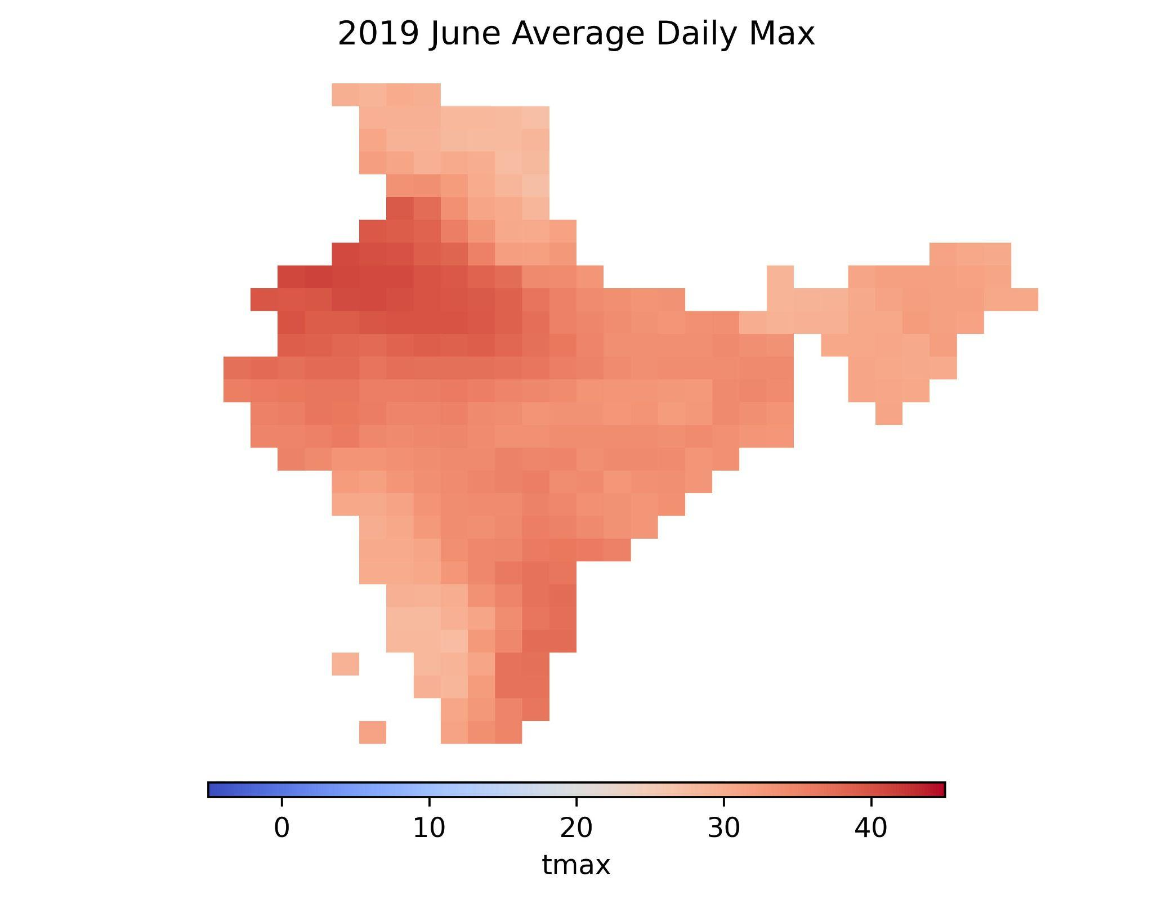
- 2019 May (f) 2019 June

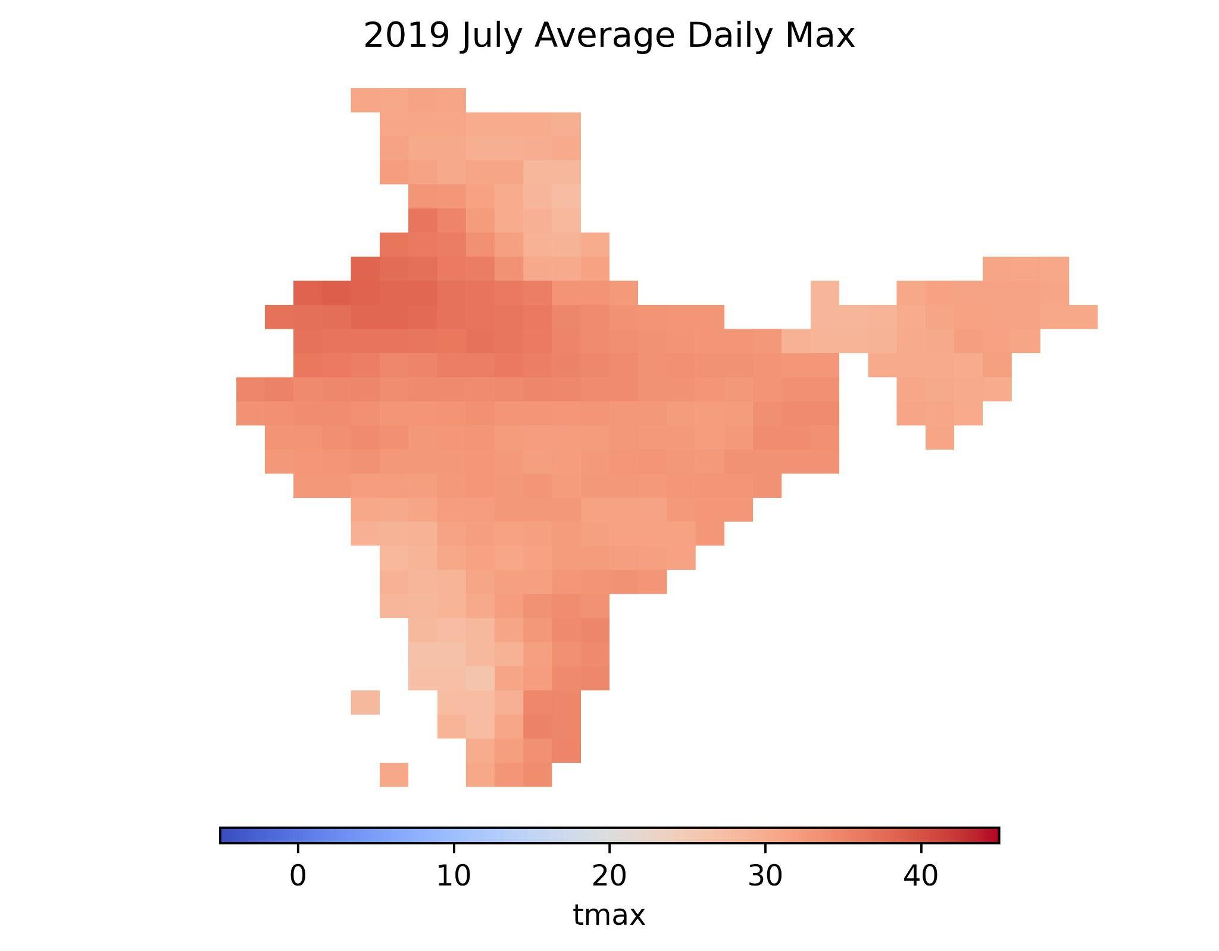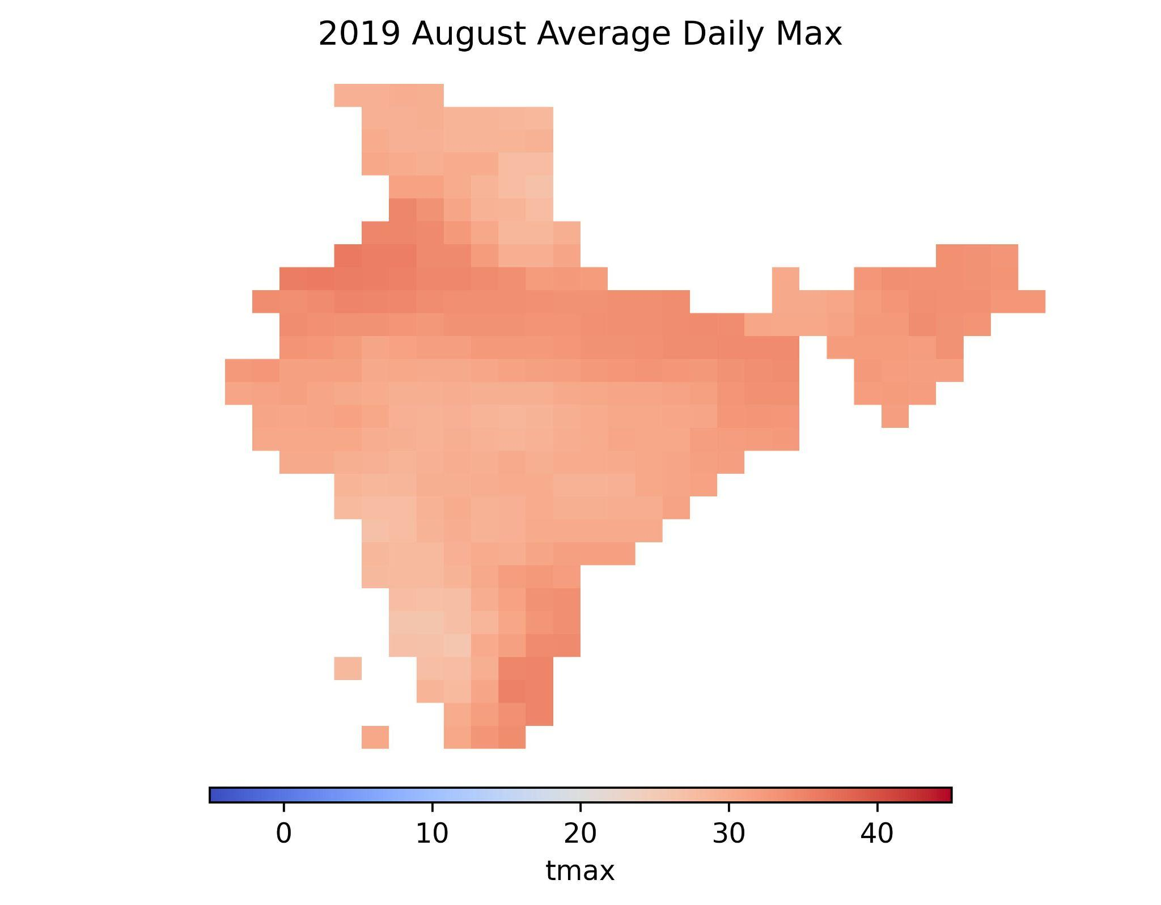
- 2019 July (h) 2019 August

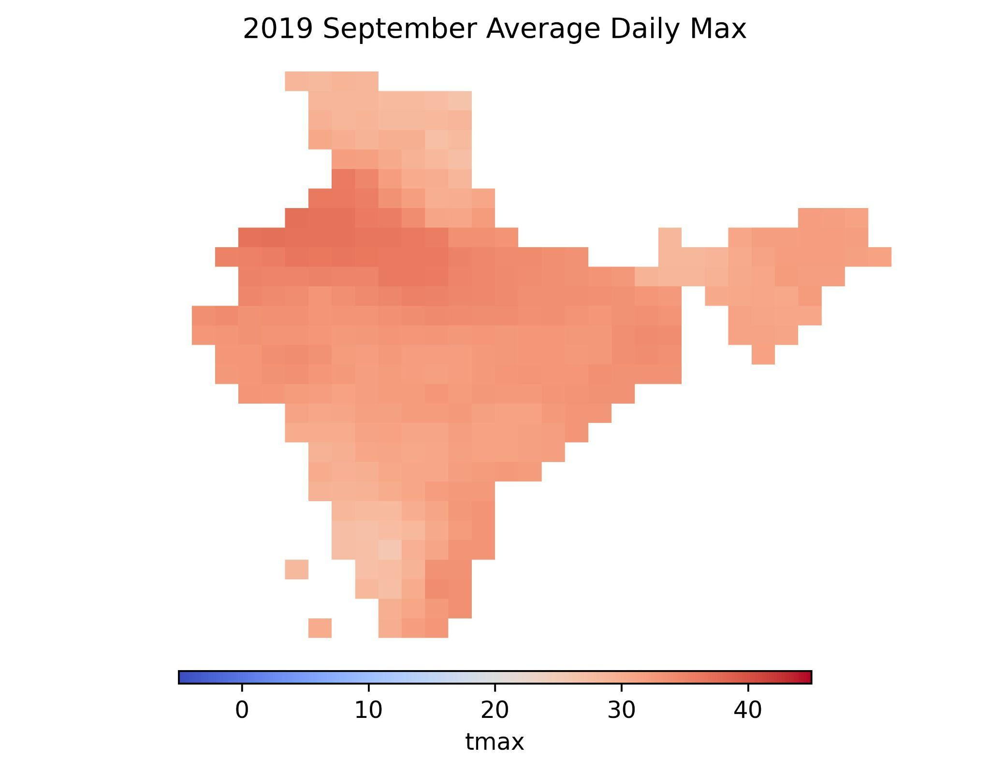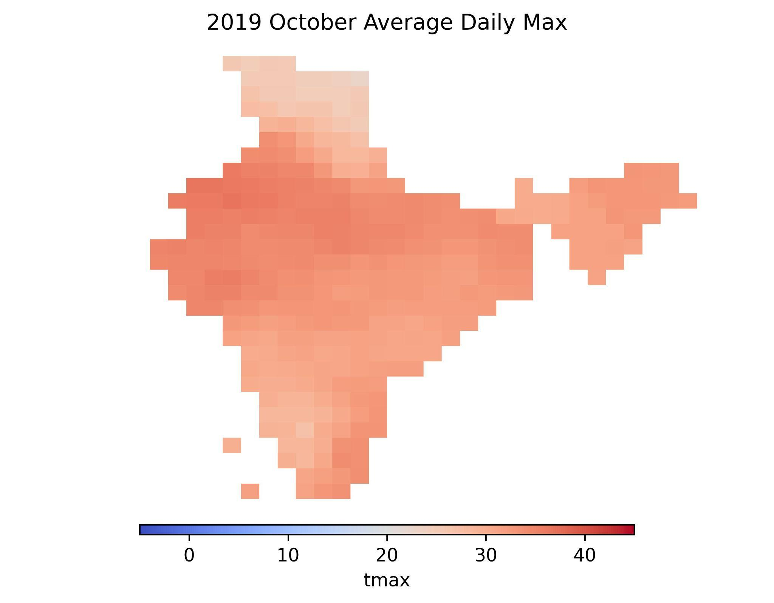
- 2019 September (j) 2019 October

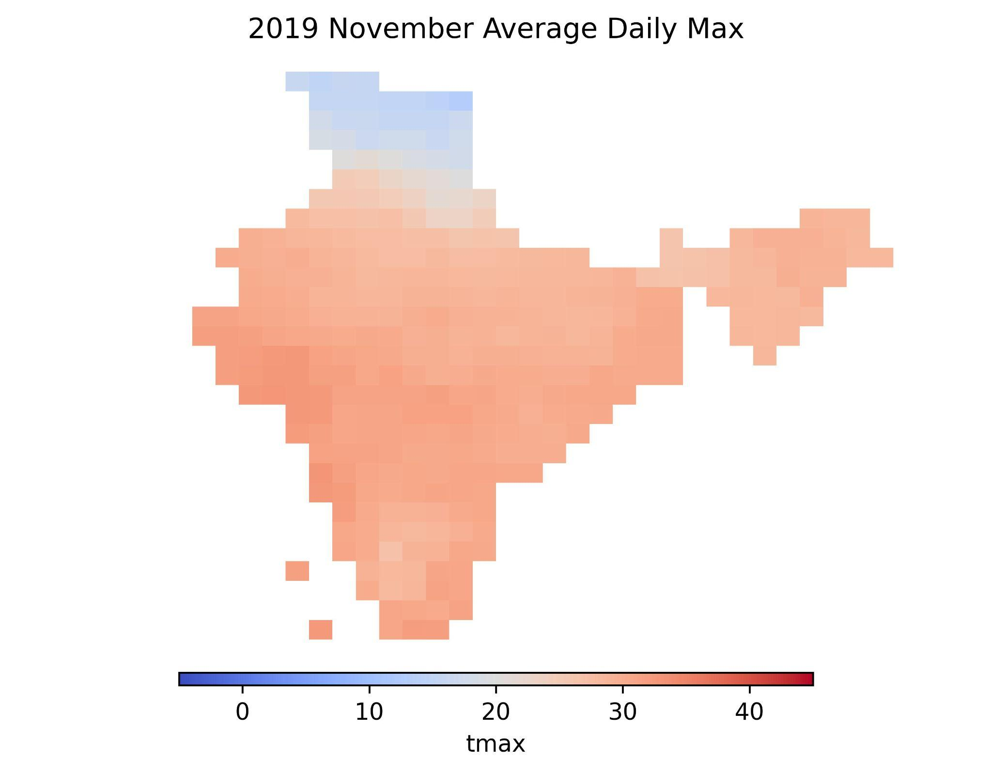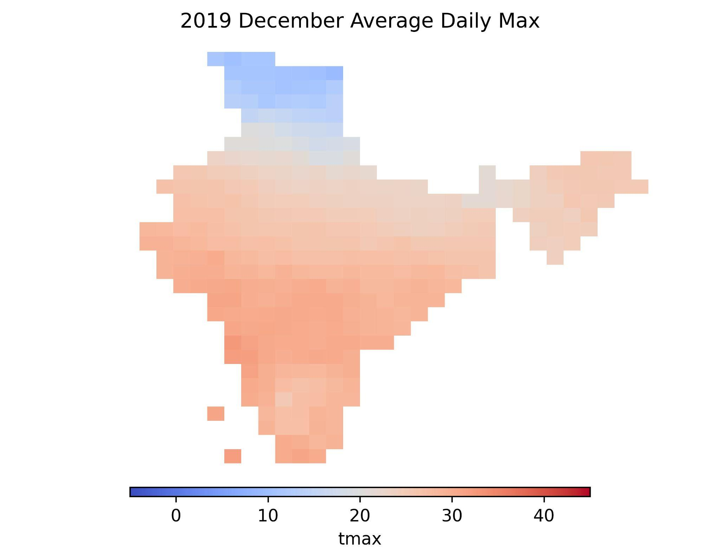
- 2019 November (l) 2019 December

Figure S.7 Maps of the moving average monthly mean of daily max temperature in India of the year 2019. Panels (a) to (l) are maps of the monthly mean of daily max temperature from January to December. Temperature data is obtained from the IMD via the Python package “IMDLIB”.

A.6 GEE modeling results for Table 1 with AR (1) error covariance structure

 | Male-specific Model |  |  | Female-specific Model |  |  | Hypothesis Testing for  Coefficient Equality between Males and Females
Variables | $\hat{β}$ estimate  (95% CI) | Std. Error | p-value | $\hat{β}$ estimate  (95% CI) | Std. Error | p-value | Z-score | p-value
Summer Max Temperature | -0.13  [-0.22, 0.035] | 0.048 | 0.0074** | 0.045  [-0.0031, 0.093] | 0.024 | 0.067. | -3.22 | 0.0013**
Summer Mean Temperature | -0.16  [-0.30, -0.019] | 0.072 | 0.026* | 0.065  [0.0034, 0.13] | 0.032 | 0.039* | -2.88 | 0.0040**
Winter Minimum Temperature | -0.03  [-0.19, 0.12] | 0.079 | 0.67 | 0.0082  [-0.063, 0.080] | 0.036 | 0.82 | -0.48 | 0.63
Winter Mean Temperature | -0.12  [-0.23, -0.0091] | 0.057 | 0.034** | 0.0096  [-0.055, 0.074] | 0.033 | 0.77 | -1.98 | 0.48
Hot Day Counts | -0.0072  [-0.011, -0.0038] | 0.0017 | < 0.001** | 0.00020  [-0.0022, 0.0026] | 0.0012 | 0.87 | -3.47 | 0.00052*
Cold Day Counts | -0.00017  [-0.0080, 0.0076] | 0.0040 | 0.97 | -0.00035  [-0.0033, 0.0026] | 0.0015 | 0.82 | 0.043 | 0.97
Significant codes: 0 ‘***’ 0.001 ‘**’ 0.01 ‘*’ 0.05 ‘.’ 0.1 ‘ ’ 1

Table S.3 Table of coefficient estimates, 95% confidence interval, p-value for statistical significance, the z-score, and p-value for the hypothesis testing of gender equality for the male and female specific models constructed with GEE and AR(1) covariance structured error terms.

A.7 Gender-specific Birth Rate Trend in India

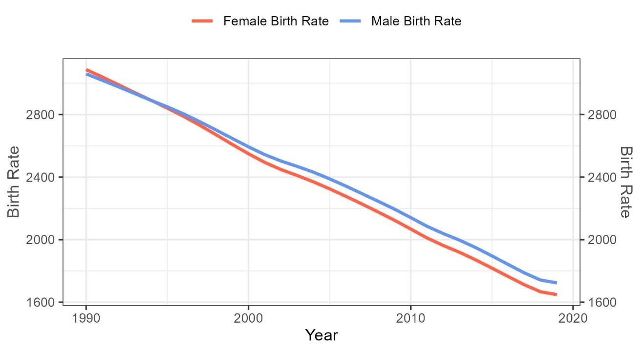
Figure S.8 Time series plot of the India gender-specific birth rates from 1990 to 2019. Female birth rates are colored in red; Male birth rates are colored in blue. Birth rate units are births per 100,000 people. Birth rate data are obtained from the Global Burden of Disease Database.

References

- Benmarhnia, T., Deguen, S., Kaufman, J. S., & Smargiassi, A. (2015). Review Article: Vulnerability to Heat-related Mortality. Epidemiology, 26(6), 781–793. https://doi.org/10.1097/EDE.0000000000000375
- Dimitrova, A., Ingole, V., Basagaña, X., Ranzani, O., Milà, C., Ballester, J., & Tonne, C. (2021). Association between ambient temperature and heat waves with mortality in South Asia: Systematic review and meta-analysis. Environment International, 146, 106170. https://doi.org/10.1016/j.envint.2020.106170

